Soccer Database Project

Database CIS8040 Fall 2017 Group Project

November 28, 2017

Team Members

Ayushri Bhargava

Girraj Maheshwari

Nilabh Sinha

Siddharth Kapoor

Shourya Paranjape

Vineela Mellachervu

Table of Contents

Introduction 3

Database Solution Outline 3

Soccer rules 4

Key Data Entity Definitions 5

Player 5

Team 5

Player_Match 5

Team_league_season 5

League 5

Season 5

Stadium 5

Key Data Issues 5

Logical Data Model 6

Table Design and Implementation 7

Data Integration: Extract, Load, and Transformation 7

Data extraction 7

Data loading and transformation 9

DATA ANALYSIS 11

Structured data 11

Unstructured Data 17

Mongo DB: Unstructured Data analysis 20

DATA SUMMARY CONCLUSION 22

APPENDIX A – Table creation script 30

APPENDIX B – Semantria results 30

APPENDIX C – SQL Results 30

APPENDIX D – Data table docs 30

APPENDIX E – Data Extraction 30

APPENDIX F – Data Extraction- Unstructured Data 30

# Introduction

**Soccer** is a popular sport played between two teams. It is played by 250 million players in over 200 countries and dependencies, making it the world's most popular sport.

Each team consists of a maximum of eleven players (excluding substitutes), one of whom must be the goalkeeper. The game is played on a rectangular field with goals at each end. The objective of the game is to score by getting the ball into the opposing goal.

Our project aims to create a database which can be utilized to predict outcomes, entertaining stories reporting statistics that enhance the viewers experience of soccer matches and gathering valuable insights to make relevant comparisons by considering player data, match data and corresponding data from soccer leagues. Data utilized for this project has been taken from past two years. The leagues for which data is mined are from English Premier League and La-Liga.

# Database Solution Outline

* Data Sources:
  + [ESPN FC Census](http://www.espn.com/soccer) - Match data was extracted from this website.
  + [world football net api](http://football-api.com/plans/world-football/) - Player attributes were web scraped from this website.
  + [Twitter](http://www.twitter.com) – User reviews about teams were extracted for sentiment analysis
* Data extraction:
  + Data extracted from source HTML content using python libraries 'BeautfulSoup4' and 'getlibrary'
  + User reviews on teams from twitter.
* Model creation steps:
  + Conceptualized and created Crow foot ER diagram considering entities and attributes of soccer
  + Creation of ID for each attribute in various tables
  + Normalization of data to 3NF
* Database integration and setup:
  + MySQL 6.3 used for creation of SQL tables and data loading
* Data analysis:
  + Data analyzed by creating SQL queries and visualized using Tableau
  + Sentiment analysis of user reviews using Semantria excel add-on.

# Soccer rules

A league consists of 20 teams. Each team faces every other team in the league twice, one on the home ground and other on away ground. In total, there are 380 matches in a league. League happens every year called seasons. We have considered two seasons 2015-16 and 2016-17 for our database design. Each match which is played by home team and away team consists of 11 players each with some substitutes.

Players are specialized as attacker, defender or midfielder. Each team tries to maintain the composition of all three specialties. Player helps in scoring, assisting or saving a goal. They also get penalized for fouls committed and get wither yellow/red cards based on severity of fouls.

When a match is played between teams, the winner is decided based on number of goals on another team. The team which scores more goals wins the game and in case of equal number of goals scored, the match is considered as a draw.

A stadium where a match is played is home ground for a club. Each stadium has a different seating capacity.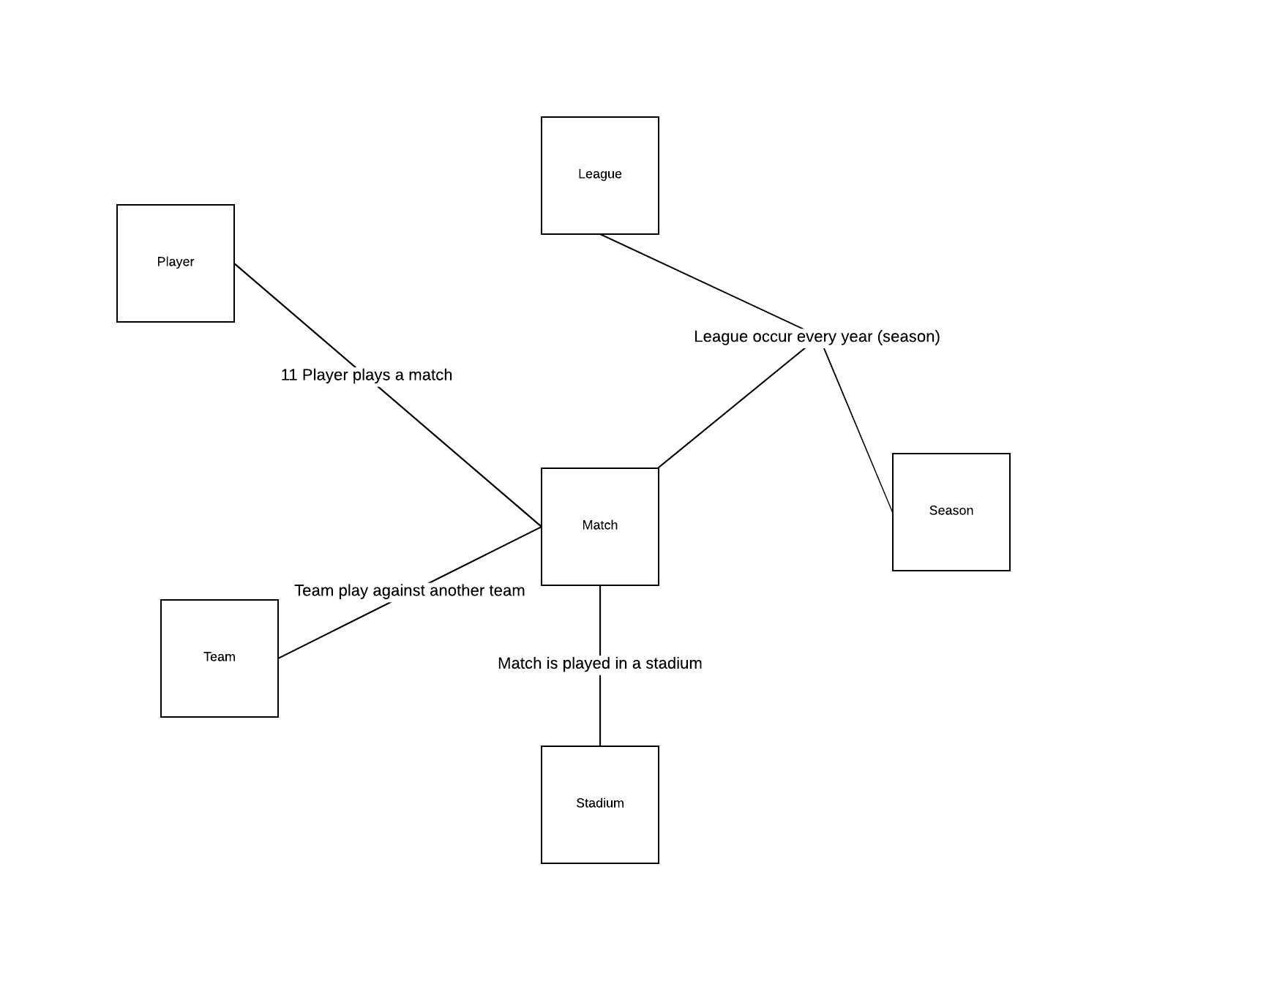

## Key Data Entity Definitions

### Player

Player table consist of attributes of the player; Name, Date of birth, Height, Position, Nationality, Weight. Data of 2189 players are captured.

### Team

Team table consists of all 46 teams that played in two leagues for past two seasons.

### Player_Match

This table consists of the records of player performance in each match, including substitutes. Attributes include: Goals_Saves, Total_Goals, Total_Shots, Shots_on_Target, fouls committed, and number of cards due to fouls.

### Team_league_season

This table represents team performance in a league for a season. Attributes captured are the team

ranks of a season.

### League

This table consist of a list of leagues. We have considered English premier league and La-Liga for our project.

### Season

League occurs every season. Data of past two seasons i.e 2015-16 and 2016-17 are extracted.

### Stadium

Every team has a home ground. Each ground hosts many matches. Data of 1331 stadiums with their attributes: city, club, country and name were extracted.

## Key Data Issues

* Data was collected from various data sources and had variation in format and nomenclature. For example, player names are not uniform throughout the sources. So, creation of unique ID and mapping was a challenge. We tried to make them uniform using excel and python.
* During the bidding process, a club of a player might be changed. We do not have the transfer data, so we assumed that a player's team is the same for the match in which the player last played.
* Rank of a team is not derived only from point and different leagues have different rules regarding rank of a team, this lead us to create a new entity team league season in our database.

# Logical Data Model

The following is the Entity Relation diagram for our soccer database. Relations are described using text on the connecting lines.

Match_level, PlayerMatch and Team_League_Season are ternary relationships. Primary keys are mentioned as PK and foreign keys as FK.

Find data table excel print (here)

Rules and assumptions:

* A player plays many matches and each match is played by many players. Some player might not even play a single match.
* Team plays a match in a league for various seasons. Team plays against another team. One team is home team and another one is away team.
* Team can play in multiple leagues and multiple seasons.
* A Stadium can host multiple matches, but a match is only played in one stadium. Some stadiums might not have any matches
* Each season has many matches, but a match can be a part of only one season.

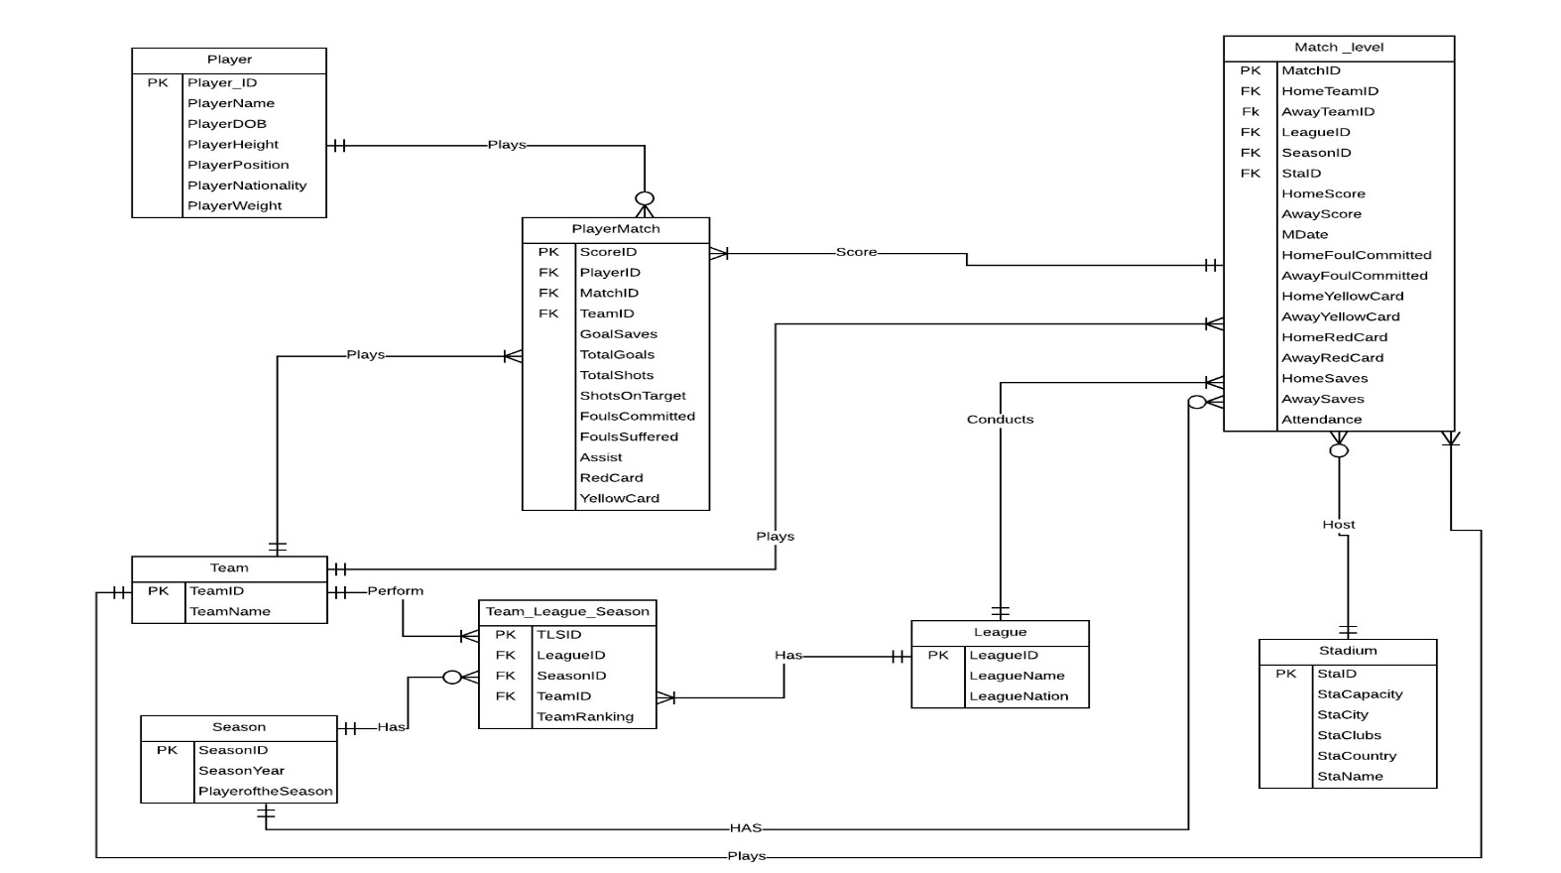

# Table Design and Implementation

Initially the data was loaded into the table from sources without normalization. All the primary keys were identified. The partial and transitive dependencies in the data were removed in order to convert our data into 3NF form. Also, checks were made to remove all the data redundancies and the corresponding columns were adjusted. For associative entities, we created a single new primary key attribute to replace a composite primary key, to efficiently retrieve the data from tables.

# Data Integration: Extract, Load, and Transformation

### Data extraction

* Data is extracted using python re package from the source websites (ref: Database source outline)
* HTML source code has been extracted and python queries are written to extract the same in structured format.
* Once data is extracted, name of the tables and attributes are labeled. Unique ID’s are created for attributes in every table. Unique ID assigned for composite primary keys.

Sample Code to extract the data from HTML source: code

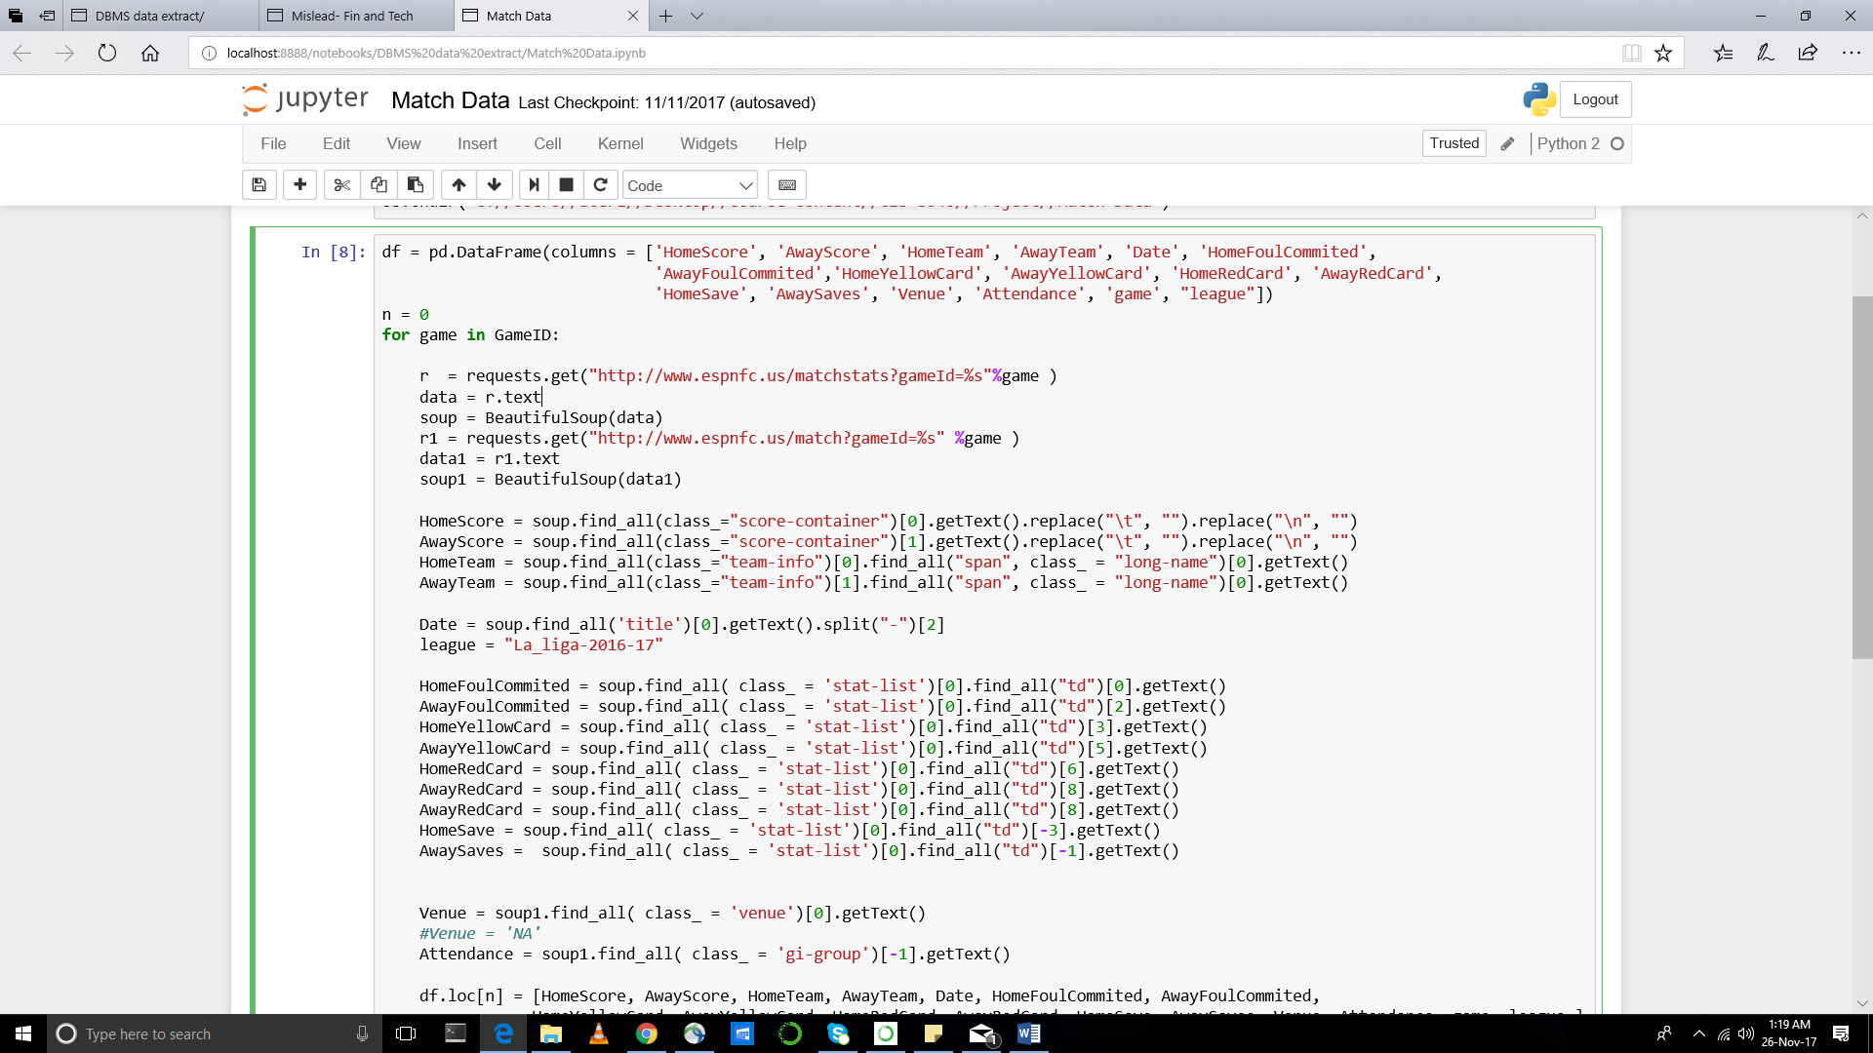

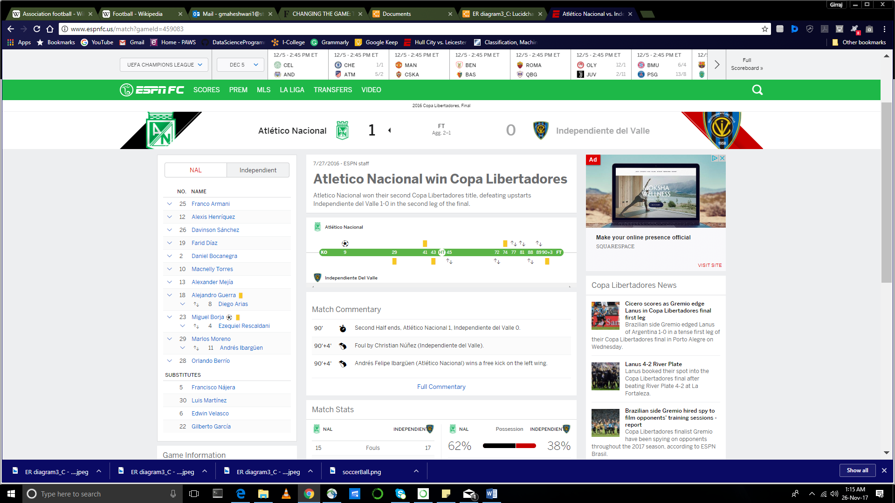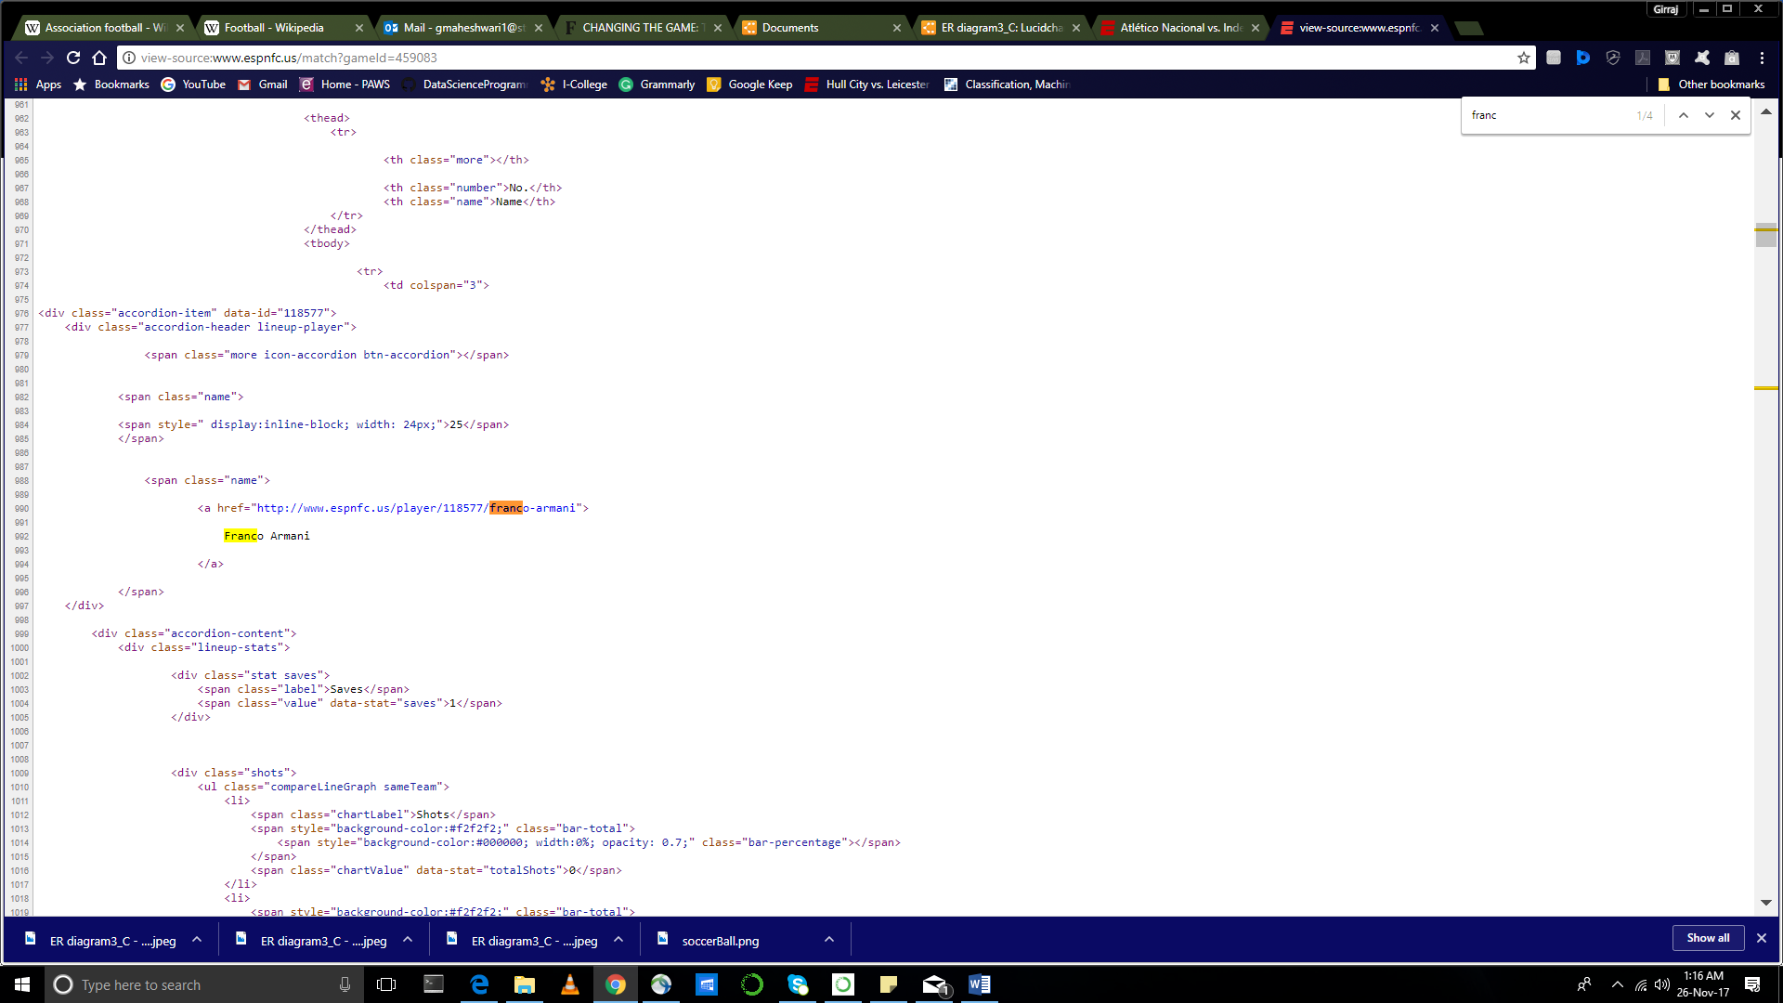

### Data loading and transformation

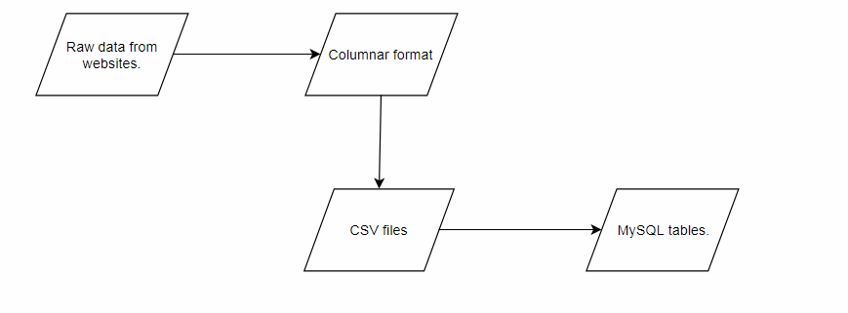

* All the data was scraped from website sources as mentioned above. Python scripts were utilized to pull data and pre-process data.
* The data was then transformed into columnar format by using Microsoft Excel.
* In this process, while in excel format, all primary key values and foreign key values were inserted into the columns. Also, date formats were adjusted to match SQL DATE ‘YYYY-MM-DD’ format.
* Since the number of rows were large, it would be a tedious task to write insert queries for each row. Hence the data has was converted into a comma delimited (.csv) file format.
* Database was created in MySQL using DDL scripts (Appendix A). Below are some sample statements for creating tables and defining relationships between tables.

CREATE TABLE `league` (

`LeagueID` varchar(15) NOT NULL,

`LeagueName` varchar(255) DEFAULT NULL,

`LeagueNation` varchar(255) DEFAULT NULL,

PRIMARY KEY (`LeagueID`)

) ENGINE=InnoDB DEFAULT CHARSET=utf8;

CREATE TABLE `team_league_season` (

`TLSID` varchar(15) NOT NULL,

`LeagueID` varchar(15) DEFAULT NULL,

`SeasonID` varchar(15) DEFAULT NULL,

`TEAMID` varchar(15) DEFAULT NULL,

`TeamRanking` varchar(15) DEFAULT NULL,

PRIMARY KEY (`TLSID`),

KEY `fk_TLSteamid` (`TEAMID`),

KEY `fk_TLSleagueid` (`LeagueID`),

KEY `fk_TLSseasonID` (`SeasonID`),

CONSTRAINT `fk_TLSleagueid` FOREIGN KEY (`LeagueID`) REFERENCES `league` (`LeagueID`),

CONSTRAINT `fk_TLSseasonID` FOREIGN KEY (`SeasonID`) REFERENCES `season` (`SeasonID`),

CONSTRAINT `fk_TLSteamid` FOREIGN KEY (`TEAMID`) REFERENCES `team` (`TEAMID`)

) ENGINE=InnoDB DEFAULT CHARSET=utf8;

* MySQL workbench’s data import wizard utility provides a simple solution to the data loading process. The source .csv file is selected as per the table which is to be loaded. The wizard reads the comma delimited file and automatically recognizes columns corresponding to the table.  
    
  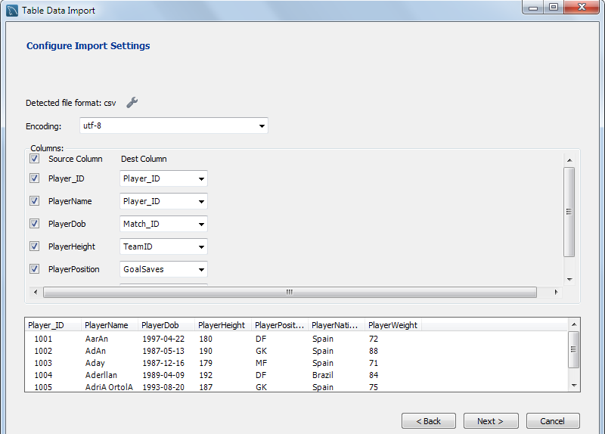

After making a few setting changes, the load process quickly inserts data into each table.

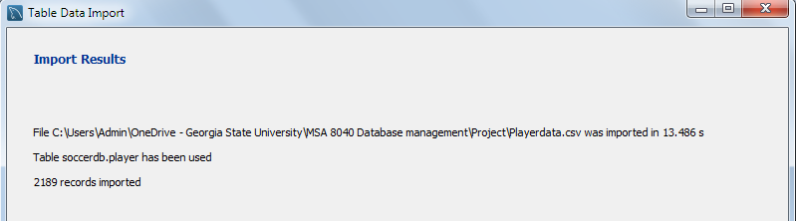

# DATA ANALYSIS

This section contains a series of data analysis queries to explore the soccer database and point out some interesting findings. In addition, at the end of the section, we give an example of the difference in writing the SQL against the raw staging data and final data model.

In the next section, we will show the data conclusion from these queries (Visualization)

Result data: (sql results)

### Structured data

1. **Points Table: Team Standings in different leagues in different seasons-**  This table will give a glimpse of overall season with each team's performance. Team's ranking with key performance parameters will be shown when we put the season and league's name in the global variable.
   1. **Code**

set @league := 'English Prem League';

set @season := '2015-16';

select *,(3*WIN+Draw) as Points

from

(

select M.teamname,M.seasonyear,M.leaguename,

home_matches+away_matches as Matches,

Home_wins+away_wins as WIN,

Home_loss+away_loss as Loss,

Home_draw+away_draw as Draw,

home_goals_scored+away_goals_scored as Goal_Scored,

home_goals_conceded+away_goals_conceded as Goal_conceded,

(home_goals_scored+away_goals_scored)-(home_goals_conceded+away_goals_conceded) as Goal_Difference

from

(

select a.teamname,c.seasonyear,d.leaguename,

count(distinct b.match_id) as home_matches,

count(distinct case when homescore>awayscore then b.match_id else null end) as Home_wins,

count(distinct case when homescore<awayscore then b.match_id else null end) as Home_loss,

count(distinct case when homescore=awayscore then b.match_id else null end) as Home_draw,

sum(HomeScore) as home_goals_scored,

sum(awayScore) as home_goals_conceded,

sum(HomeScore)-sum(awayScore) as home_goal_difference

from team as a

left join match_level as b

on a.TEAMID=b.HomeTeamID

left join season as c

on b.seasonid=c.SeasonID

left join league as d

on b.leagueid=d.LeagueID

where seasonyear= @season

and LeagueName= @league

group by 1,2

order by 5 desc) as M

left join

(

select a.teamname,c.seasonyear,d.leaguename,

count(distinct b.match_id) as away_matches,

count(distinct case when awayscore>homescore then b.match_id else null end) as Away_wins,

count(distinct case when awayscore<homescore then b.match_id else null end) as Away_loss,

count(distinct case when awayscore=homescore then b.match_id else null end) as Away_draw,

sum(AwayScore) as away_goals_scored,

sum(homeScore) as away_goals_conceded,

sum(AwayScore)-sum(homeScore) as away_goal_difference

from team as a

left join match_level as b

on a.TEAMID=b.AwayTeamID

left join season as c

on b.seasonid=c.SeasonID

left join league as d

on b.leagueid=d.LeagueID

where seasonyear= @season

and LeagueName= @league

group by 1,2

order by 5 desc) as N

on M.teamname=N.teamname

and M.seasonyear=N.seasonyear

and M.leaguename=N.leaguename

) as P

order by points desc

* 1. **Result**

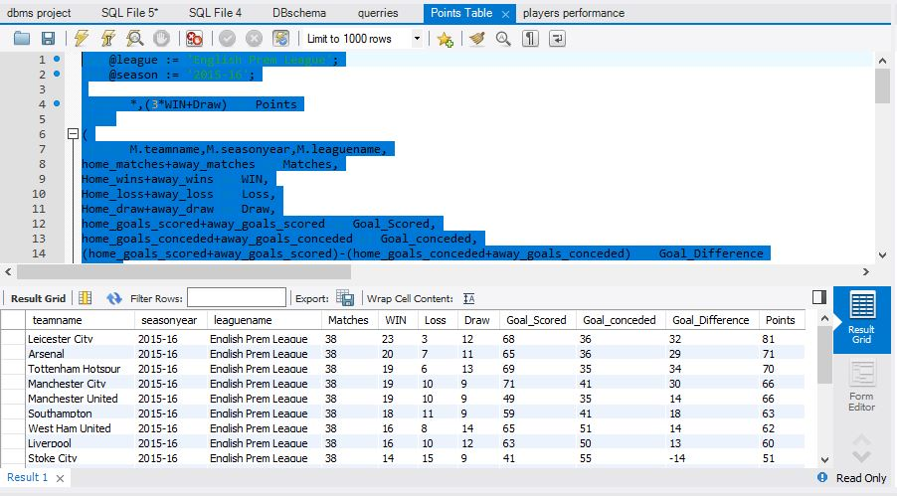

* 1. **Interpretation**

**This table gives us the final standings of the teams in a league for a season. We must enter the league name and season at the top in global variable declaration. It also presents a complete picture of a team in that season with variables like - no. of wins, loss, points, goals scored, goals conceded, etc.**

**Tables used:** Team, Match_Level, Season, League

1. **Player Statistics: This code will give the key player's performance parameter which will help in judging a player's ability.**
   1. **Code**

**select *,**

**round(Goals_2015_16*100/shots_2015_16,2) as accuracy_2015_16,**

**round(Goals_2016_17*100/shots_2016_17,2) as accuracy_2016_17**

**from(**

**select playername,**

**sum(totalgoals) as TotalGoals,**

**sum(case when seasonyear='2015-16' then totalgoals else null end) as Goals_2015_16,**

**sum(case when seasonyear='2016-17' then totalgoals else null end) as Goals_2016_17,**

**sum(case when seasonyear='2015-16' then assist else null end) as assist_2015_16,**

**sum(case when seasonyear='2016-17' then assist else null end) as assist_2016_17,**

**sum(case when seasonyear='2015-16' then totalshots else null end) as shots_2015_16,**

**sum(case when seasonyear='2016-17' then totalshots else null end) as shots_2016_17**

**from (**

**select a.scoreid,a.player_id,d.playername,a.match_id,a.totalshots,a.totalgoals,a.assist,**

**b.seasonid,c.seasonyear,c.playeroftheseason,b.hometeamid,b.awayteamid**

**from playermatch a**

**left join match_level b**

**on a.Match_ID=b.match_ID**

**left join season as c**

**on b.seasonID=c.SeasonID**

**left join player as d**

**on a.Player_ID=d.Player_ID**

**group by a.scoreid,a.player_id,d.playername,a.match_id,a.totalshots,a.totalgoals,a.assist,**

**b.seasonid,c.seasonyear,c.playeroftheseason,b.hometeamid,b.awayteamid) as M**

**group by 1**

**order by TotalGoals desc) as N**

* 1. **Results**

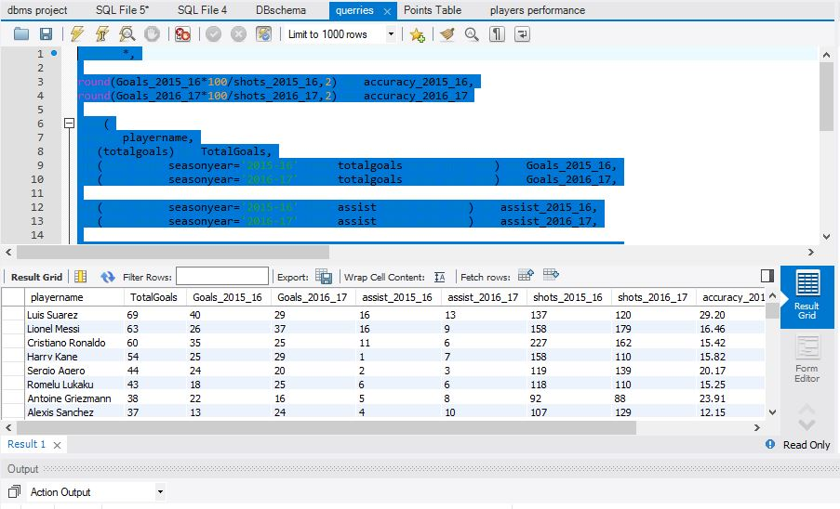

* 1. **Interpretations**

**This table shows player’s complete analysis over the last two years. It includes goals scored, assists made, shots taken, accuracy, etc. in different seasons. By this we can compare player’s performance with respect to others as well as his own performance over the years. Luis Suarez, FC Barcelona striker is the most lethal player in the past two years as far as scoring goals are concerned.**

1. **Stadiums: This will help us in finding the key attributes of a stadium and give us interesting facts about the biggest stadium in Europe, which stadium is fully occupied and in which European city it is situated.**
   1. **Code**

**select a.staid,a.staname,a.stacapacity,**

**a.staCountry ,a.StaClubs,**

**round(avg(b.attendance),0) as attendance**

**from stadium as a**

**left join match_level as b**

**on a.staid=b.staid**

**group by 1,2,3,4,5**

**order by 6 desc**

* 1. **Results**

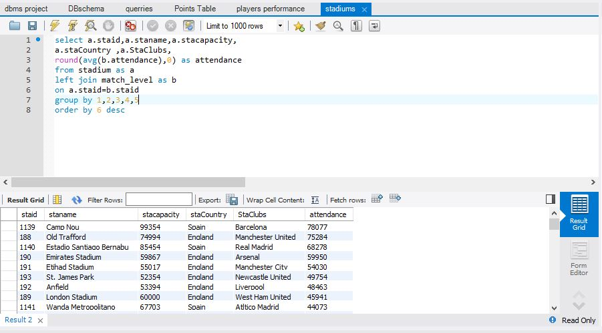

* 1. **Interpretation**

**This table gives us the average number of attendees of all the games in a stadium and thus compares the fan base of different teams. Camp Nou, situated in Barcelona is the biggest stadium in Europe with a capacity of nearly 100,000 and has an average attendance of 78,000**

1. **Goalkeeper saves: This will help us in comparing goalkeeper's performance over the entire season. Goalkeeper's attributes are very different from that of an attacker, due to which we have analyzed it in a separate table.**
   1. **Code**

**select playername,**

**sum(GoalSaves) as TotalGoalsaves**

**from (**

**select d.playername,a.match_id,a.totalshots,a.totalgoals,a.assist,**

**b.seasonid,c.seasonyear,b.hometeamid,b.awayteamid,a.GoalSaves,b.HomeScore,b.AwayScore**

**from playermatch a**

**left join match_level b**

**on a.Match_ID=b.match_ID**

**left join season as c**

**on b.seasonID=c.SeasonID**

**left join player as d**

**on a.Player_ID=d.Player_ID**

**group by d.playername,a.match_id,a.totalshots,a.totalgoals,a.assist,**

**b.seasonid,c.seasonyear,b.hometeamid,b.awayteamid,a.GoalSaves,b.HomeScore,b.AwayScore) as M**

**group by 1**

**order by TotalGoalsaves desc**

* 1. **Results**

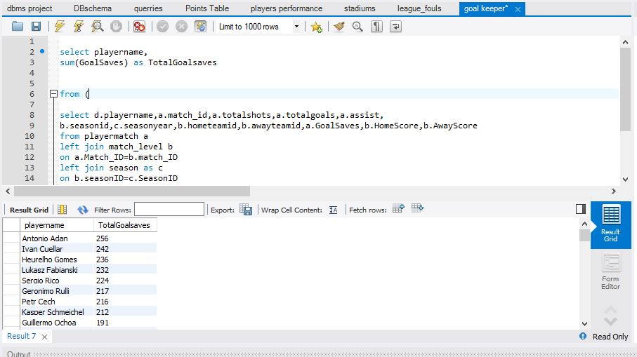

* 1. **Interpretation**

**This query compares the expertise of a goalkeeper across both the season**

1. **Ballon’dor Winner: This table gives us the best player of the season in Europe, number of goals he has scored, assists he has made, etc.**
   1. **Code**

select A.seasonyear,A.Ballondor_winner,B.matches,B.goals,B.assists

from

(

select a.SeasonID, a.seasonyear,b.Player_ID,b.PlayerName as Ballondor_winner

from season as a

left join

player as b

on a.Playeroftheseason=b.Player_ID

group by 1,2,3,4) as A

left join

(

select a.player_id,b.seasonID,

count(distinct a.Match_ID) as matches,

sum(TotalGoals) as goals,

sum(Assist) as assists

from playermatch as a

left join match_level as b

on a.Match_ID=b.match_ID

group by 1,2) As B

on A.SeasonID=B.SeasonID

and A.Player_ID=B.Player_ID

where seasonyear in ('2015-16','2016-17')

* 1. **Results**

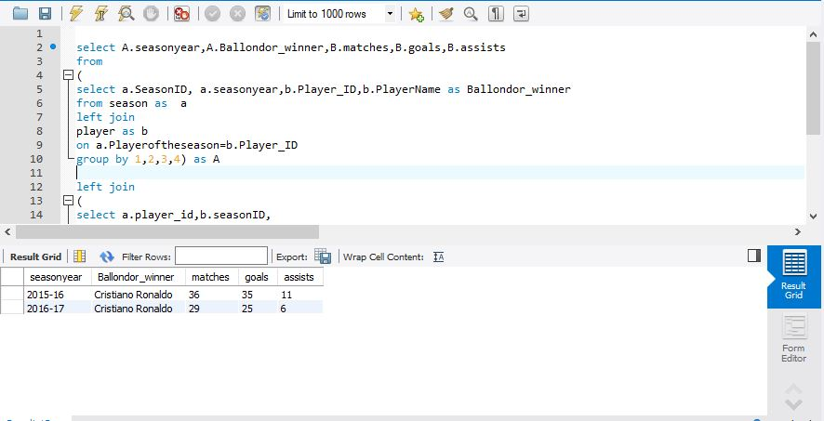

* 1. **Interpretation**

**This query shows the performance of the Europe’s best player in respective season.**

**Ronaldo comes as the best player.**

1. **League Comparison: Different leagues have different intensity of a game. This table will give the number of fouls committed, red cards, yellow cards etc. in different leagues for different seasons. We can judge which league is harder to play than the other.**
   1. **Code**

**select b.leaguename ,c.seasonyear,sum(HomeFoulCommited)+sum(AwayFoulCommited) as foul_commited,**

**sum(a.HomeRedCard)+sum(AwayRedCard) as Red_Card,**

**sum(a.HomeYellowCard)+sum(AwayYellowCard) as Yellow_Card**

**from match_level as a**

**left join league as b**

**on a.leagueid=b.LeagueID**

**left join season as c**

**on a.seasonID=c.SeasonID**

**group by 1,2**

* 1. **Results**

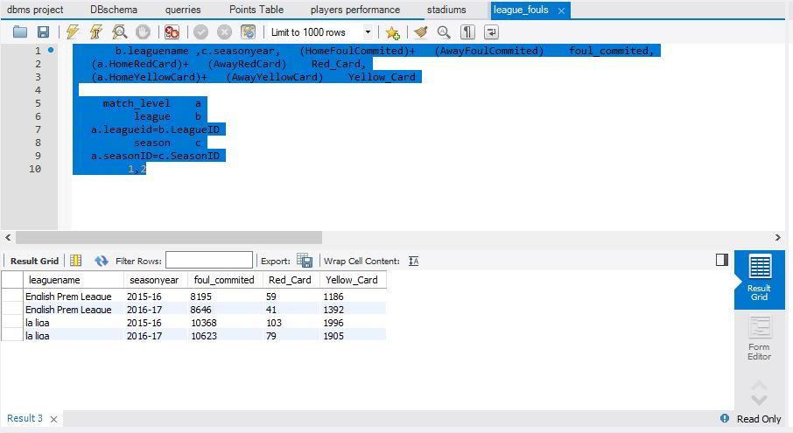

* 1. **Interpretation**

**The table shows that La Liga is rasher as compared to EPL as number of fouls committed, red cards yellow cards is way more in La Liga for both the seasons as compared to EPL.**

### Unstructured Data

1. **Sentiment Analysis: Using Python:**

Data: Twitter data which consists of user reviews about the teams. Sentiments are analysed using the python code. Extraction code

* 1. **Code**

**import nltk.classify.util  
from nltk.classify import NaiveBayesClassifier  
from nltk.corpus import names  
  
  
def word_feats(words):  
    return dict([(word, True) for word in words])  
  
positive_vocab = [ 'awesome', 'outstanding', 'fantastic', 'terrific', 'good', 'nice', 'great']  
negative_vocab = [ 'bad', 'terrible','useless', 'hate']  
neutral_vocab = [ 'the','sound','was','is','actors','did','know','words','not']  
   
positive_features = [(word_feats(pos), 'pos') for pos in positive_vocab]  
negative_features = [(word_feats(neg), 'neg') for neg in negative_vocab]  
neutral_features = [(word_feats(neu), 'neu') for neu in neutral_vocab]  
   
train_set = negative_features + positive_features + neutral_features  
   
classifier = NaiveBayesClassifier.train(train_set)   
  
 # Predict  
  
def sentiment(sentence,typ):  
    neg = 0  
    pos = 0  
    net = 0  
    #sentence = "Awesome movie, I liked it"  
    sentence = sentence.lower()  
    words = sentence.split(' ')  
    for word in words:  
        classResult = classifier.classify( word_feats(word))  
        if classResult == 'neg':  
            neg = neg + 1  
        if classResult == 'pos':  
            pos = pos + 1  
        if classResult == 'neu':  
            net = net + 1  
    poy = float(pos)/len(words)  
    noy = float(neg)/len(words)  
    noty = float(net)/len(words)  
    if typ == 'pos':  
        return poy  
    if typ == 'noy':  
        return noy  
    if typ == 'noty':  
        return noty  
      
dff1.loc[:,"positive"] = dfff['Text'].apply(lambda x: sentiment(x,'poy'))  
dff1.loc[:,"negative"] = dfff['Text'].apply(lambda x: sentiment(x,'noy'))  
dff1.loc[:,"neutral"] = dfff['Text'].apply(lambda x: sentiment(x,'noty'))  
dff1.to_excel('/Users/sidkapoor/Desktop/twit/sentiments.xlsx')**

* 1. **Results:**

|  |  |  |  |  |  |  |  |
| --- | --- | --- | --- | --- | --- | --- | --- |
| Teams | Negative | Neutral | Positive | Grand Total | Neg% | Net% | Pos% |
| Arsenal | 5 | 56 | 763 | 824 | 1% | 7% | 93% |
| Atletico | 1 | 3 | 66 | 70 | 1% | 4% | 94% |
| Chelsea | 79 | 70 | 704 | 853 | 9% | 8% | 83% |
| Espanyol |  | 3 | 17 | 20 | 0% | 15% | 85% |
| Barcelona | 2 | 8 | 204 | 214 | 1% | 4% | 95% |
| Leicester City |  | 10 | 158 | 168 | 0% | 6% | 94% |
| Manchester City | 1 | 1 | 179 | 181 | 1% | 1% | 99% |
| Manchester United | 2 | 5 | 274 | 281 | 1% | 2% | 98% |
| Real Madrid | 17 | 29 | 269 | 315 | 5% | 9% | 85% |
| **Grand Total** | **107** | **185** | **2634** | **2926** | **4%** | **6%** | **90%** |

* 1. **Interpretations:**

**Most negative reviews: Chelsea followed Real Madrid**

**Most positive review: Manchester city followed MU followed**

#### **This interpretation is similar to the current rankings in EPL.**

#### **Real Madrid not performing good in recent times which is reflected in above table so people sentiments are negative although RM being a very good team**

1. **Sentiment Analysis: Using Semantria**

Data : Ref ( Sementria data)

Following analysis is done using Semantria on 1000 tweets

**A screenshot of a social media post

Description generated with very high confidence**

**INTERPRETATION:**

We see in the above sentiment analysis that most of the documents are either positive or mixed and a very few of them are negative. Same is the case with the phrases being used. Most of them are positive or neutral

1. **News Report coverage**

Data: News report of every 760-match extracted from ESPN.

Analysis platform: **Python**

The following word cloud show how much media attention/ or influence of a player in the match.

Credit: Word it out (<https://worditout.com>)

Here is one sample news report of a match between Barcelona and Granada

“Luis Suarez fires Barcelona past Granada to secure La Liga title”

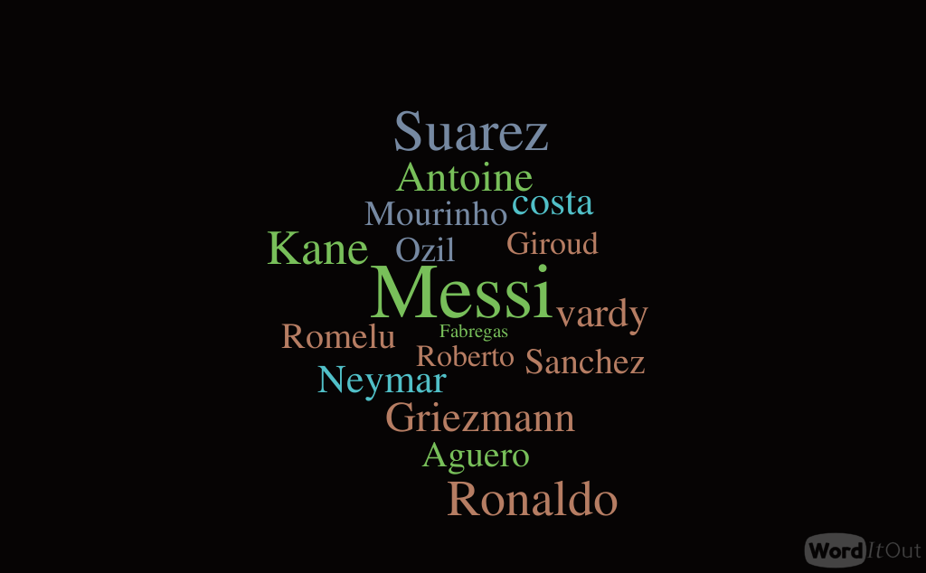

As indicated by the cloud that Messi, Neymar, Suarez comes in the news report more frequently.

### Mongo DB: Unstructured Data analysis

Below are a few MongoDB queries with their results and explanation

Data Set: Match report data of all 760 matches

Query1

Code - db.getCollection('match_comments').find({'LeagueID': 'EPL'}).count()

Result – 760

Explanation - In this, we are finding the number of matches played in La Liga league for two seasons. (2015-16, 2016-17)

Query2

Code - db.getCollection('match_comments').find({'LeagueID': 'LaLiga'}).count()

Result – 760

Explanation - In this, we are finding the number of matches played in EPL for the two seasons.

(2015-16, 2016-17)

Query3

Code - db.getCollection('match_comments').find({ $where: "this.HomeScore == this.AwayScore", 'LeagueID':'EPL'}).count()

Result – 191

Explanation - We find the total number of matches whose result was a draw and were played in EPL league. We see that 25% of the total matches ended up in a draw under the EPL League for two seasons.

Query4

Code - db.getCollection('match_comments').find({ $where: "this.HomeScore == this.AwayScore", 'LeagueID':'LaLiga'}).count()

Result – 181

Explanation - We find the total number of matches whose result was a draw and were played in La Liga league. We see that 23% of the total matches ended up in a draw under the La Liga League for two seasons.

Query5

Code - db.getCollection('match_comments').find({ $where: "this.HomeScore > this.AwayScore", 'LeagueID':'LaLiga'}).count()

Result – 364

Explanation - Here we find the number of Home teams which have won a match in La Liga league. Almost 47% of the home teams won the match in their home ground.

Query6

Code - db.getCollection('match_comments').find({ $where: "this.HomeScore > this.AwayScore", 'LeagueID':'EPL'}).count()

Result – 344

Explanation - Here we find the number of Home teams which have won a match in EPL league. Almost 45% of the home teams won the match in their home ground.

Also taking the draw data into consideration, we may conclude that home teams always have a better chance of winning than the away teams. So next time while betting, we must definitely try our luck on the home teams!!!

Query7

Code - db.match_comments.find( { LeagueID: 'LaLiga',Comments: { $regex: ".*Barcelona*" } } ).count()

Result – 78

Explanation - Here, we see that in our report data, there are around 78 reports about team Barcelona.

Query8

Code - db.match_comments.find( { Comments: { $regex: ".*Rafinha.*" } } )

Result – 1

Explanation - Out of those 78 reports, there is only one report about Rafinha.

Query9

Code - db.match_comments.find( { Comments: { $regex: ".*Neymar.*" } } )

Result – 15

Explanation - And there are 15 reports about Neymar.

Query10

Code - db.match_comments.find( { Comments: { $regex: ".*Messi*" } } )

Result – 39

Explanation - Whereas, we have around 39 reports for Messi, which is 50% of all the total reports of Barcelona team. This makes it obvious that Messi is a very efficient player and is on the headlines of most of the reports.

# DATA SUMMARY CONCLUSION

In this section we will represent the conclusion we got from the data and SQL queries.

Tool used of creation of below charts: **Tableau**

We pulled out the *data from above SQL querie*s and plot them on Tableau for Visualization and analysis

1. TOTAL NUMBER OF GOALS SCORED BY EACH PLAYER

Query 1: Ref (2.1)

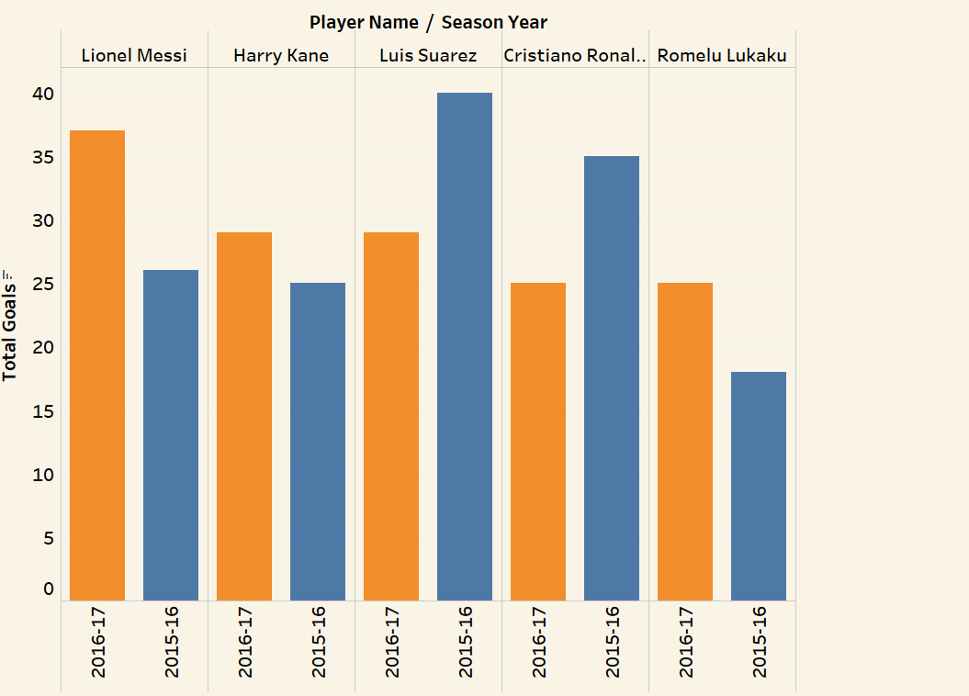

The bar graph shows total number of goals scored by the top 5 players in both the seasons, 2016-17 and 2017-18 for both the leagues. Here we see that the performance of some players declined whereas for some it ameliorated.

1. GOALS CONCEDED VS GOALS SCORED

Query1 : Ref (1.1)

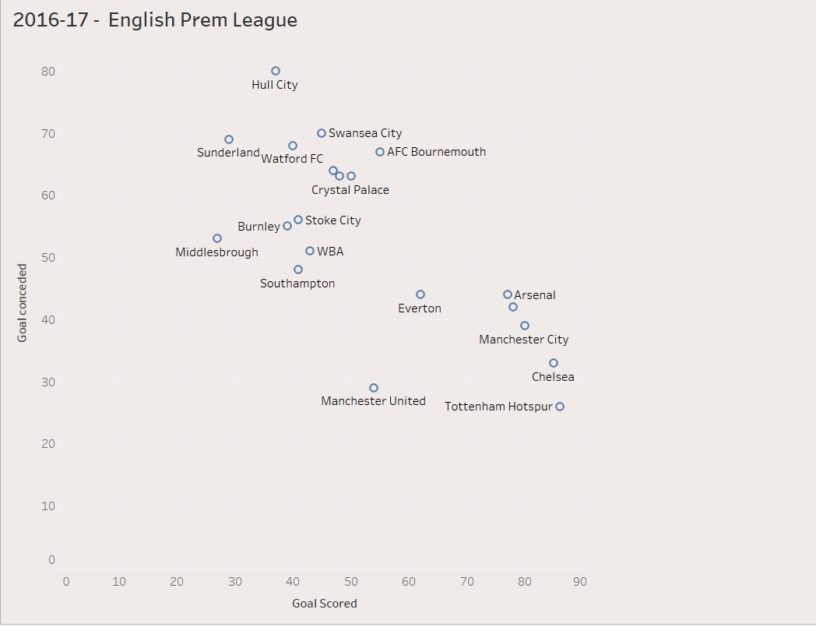

The above scatter plot shows the goals scored vs goals conceded for all the 20 teams played in 2016-17 in English Premiere League where some teams have scored more goals, and some have conceded more goals.

1. GOALS CONCEDED VS GOALS SCORED

Query 1: Ref(1.1)

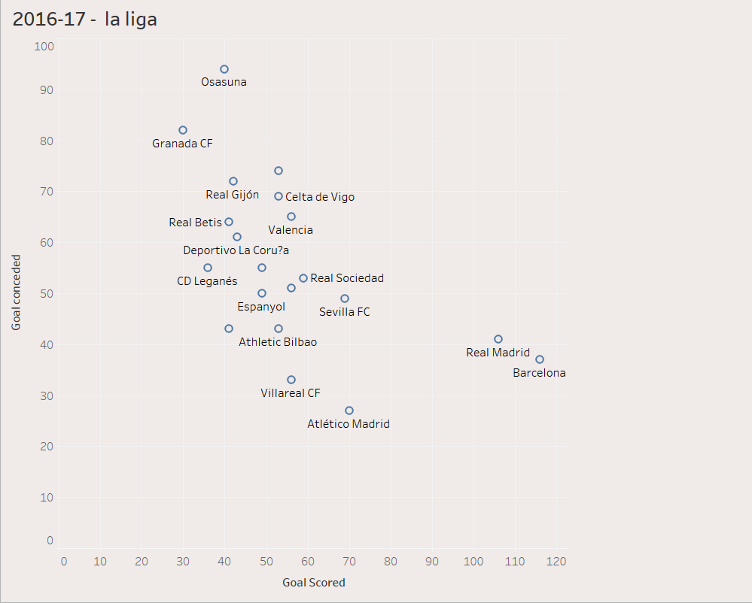

The above scatter plot shows the goals scored vs goals conceded for all the 20 teams played in 2016-17 in La Liga League where some teams like Osasuna scored more goals than goals conceded and some teams like Barcelona and Real Madrid have conceded more goals than goals scored.

1. GOALS CONCEDED VS GOALS SCORED

Query 1: Ref(1.1)

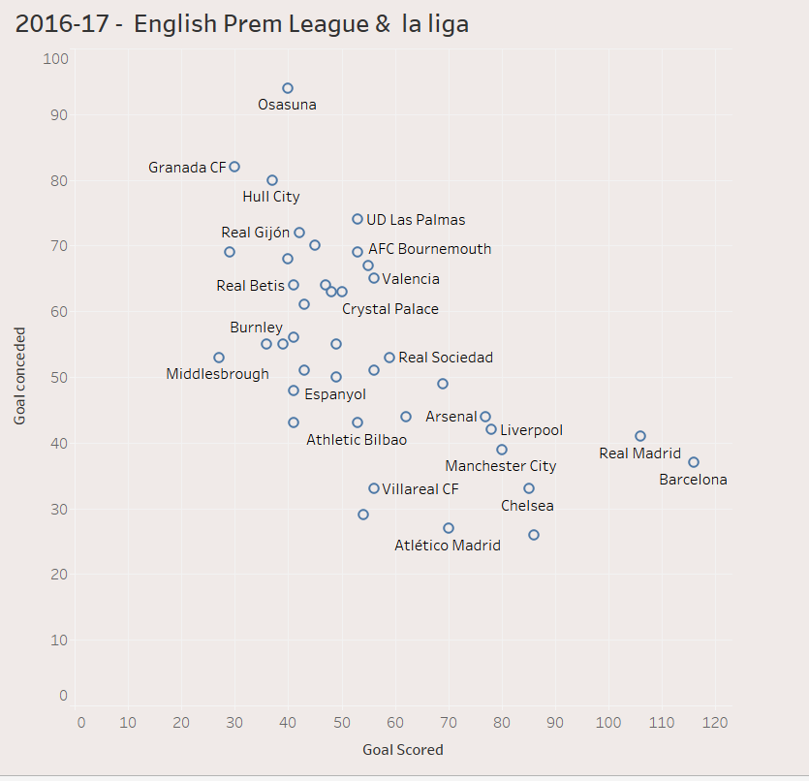

This scatter plot shows the relation between goals conceded vs goals scored for both English Premiere League and La Liga League in 2016-17.

1. TOTAL GOALS VS TOTAL ASSISTS

Query 1: Ref(2.1)

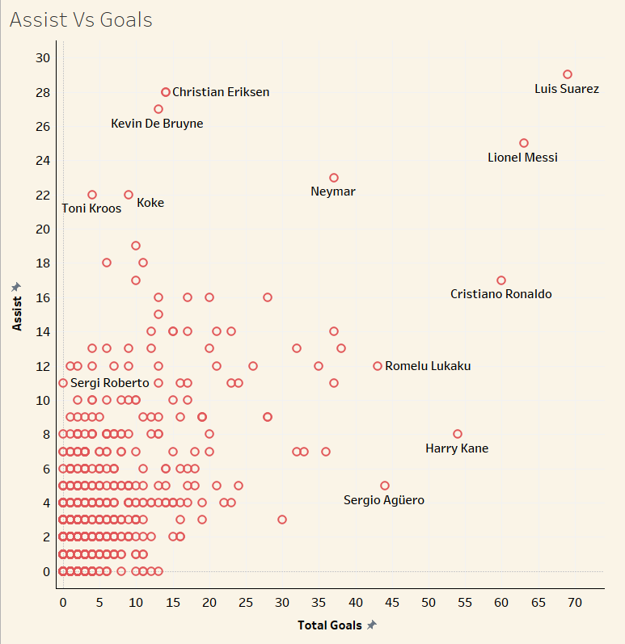

The above graph is a scatter plot showing the relation between total goals and assists for all the players. Most of the players are concentrated at the origin with moderate number of goals and assists but there are few good players like Suarez and Messi who have scored more goals and assists.

1. % ATTENDENCE VS STADIUM CAPACITY

Query 1: Ref(3.1)

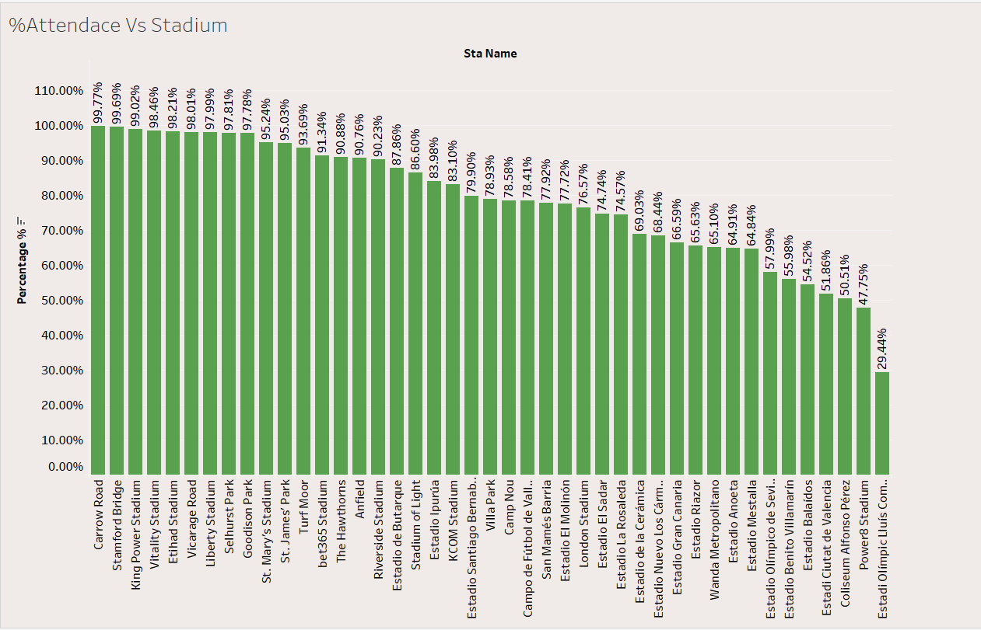

The bar graph shows the percentage of attendees and stadium’s capacity for each stadium. Stadiums like Carrow Road and Stamford Bridge have highest percentage of attendees and Estadi Olimplic has least number of attendees.

1. SHOT ACCURACIES IN 2015-16

Query 1: Ref(2.1)

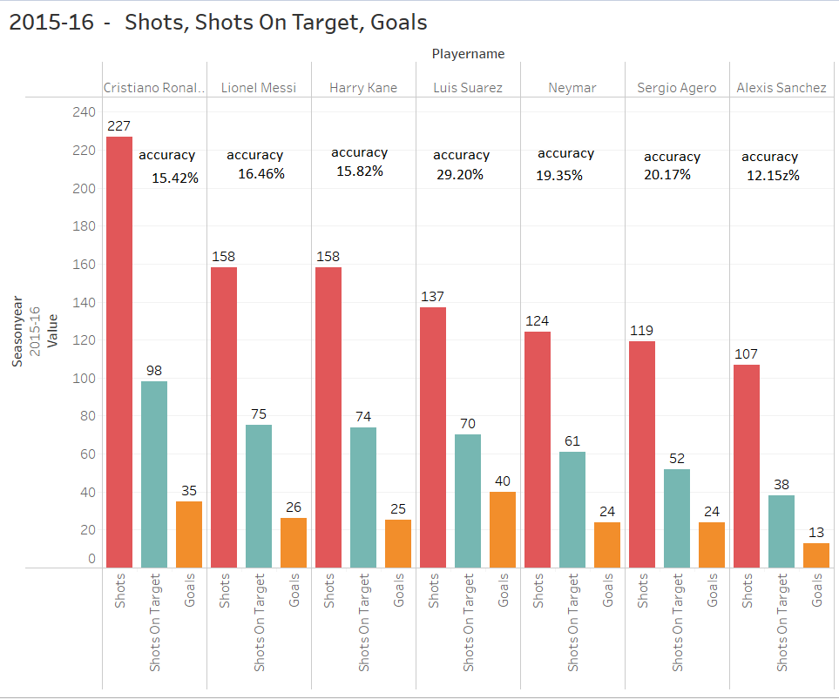

The bar graph displays the accuracy in scoring goals based on number of shots, shots on target and goals scored, for top 6 players in the year 2015-16. Here Ronaldo is hitting highest number of shots but Agero has maximum accuracy. From this we conclude that accuracy does not depend just on shots but, on both goals and shots.

1. SHOT ACCURACIES IN 2016-17

Query 1: Ref(2.1)

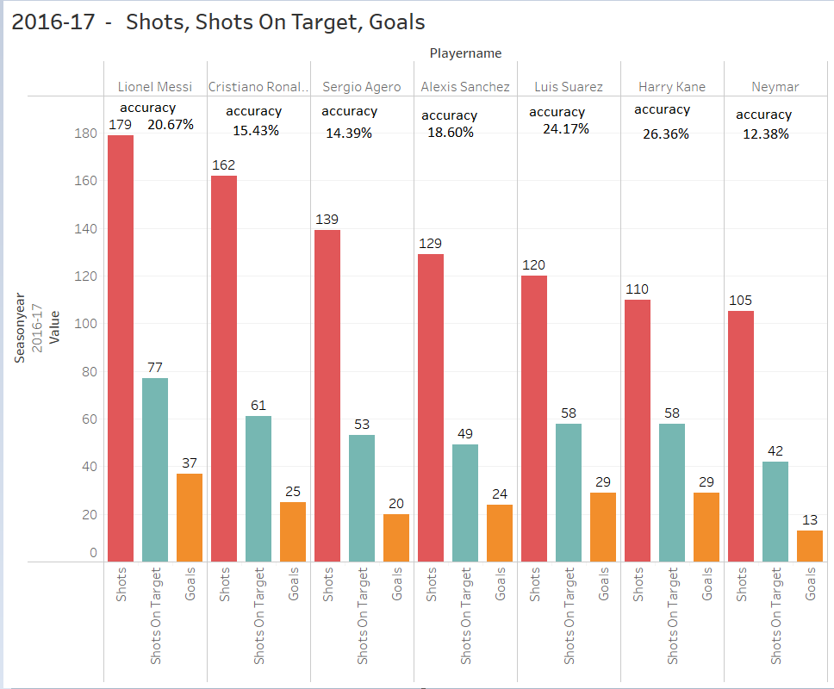

The bar graph displays the accuracy in scoring goals based on number of shots, shots on target and goals scored for top 6 players in the year 2016-17. Here Messi is hitting highest number of shots and goals, but Harry Kane has maximum accuracy, so accuracy does not depend just on shots but on both goals and shots.

# APPENDIX A – Table creation script



# APPENDIX B – Semantria results



# APPENDIX C – SQL Results



# APPENDIX D – Data table docs



# APPENDIX E – Data Extraction



# APPENDIX F – Data Extraction- Unstructured Data

